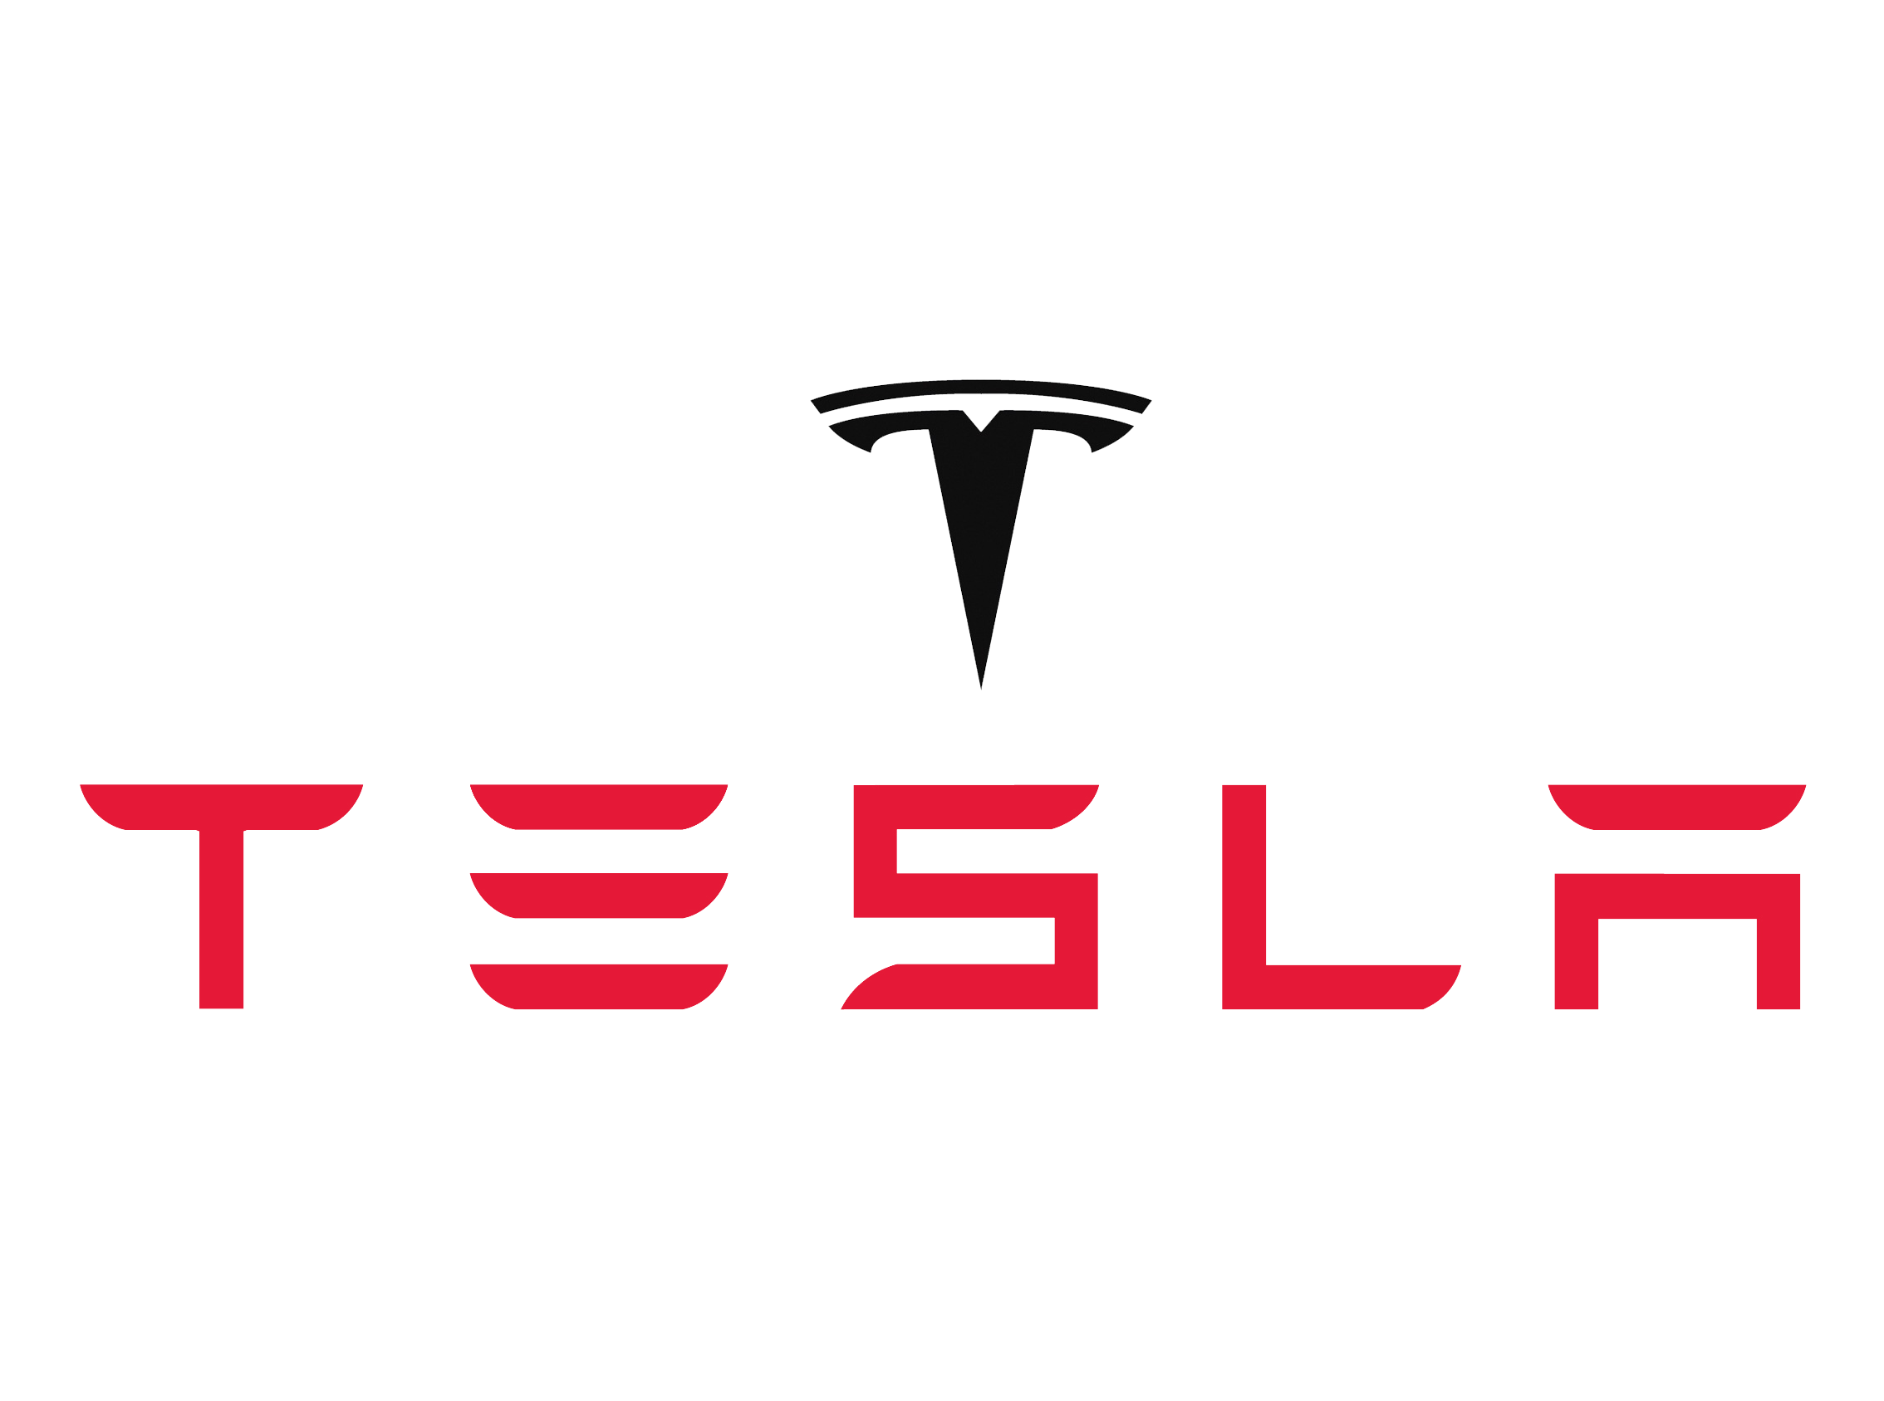

The Unexploited Strategies of Tesla, Inc.

Written by:

Clayton Kelly, Munish Umatiya, Matthew Zlotnik, Shayaan Jagtap

Group 2 - Artificial Intelligence

Executive Summary

The company we chose to dissect is Tesla, one of the world’s foremost innovative companies. For many years, Tesla has been developing a way for its cars to drive themselves, through an Artificial Intelligence program called Autopilot. Autopilot could be a primary source of competitive advantage for Tesla, because it satisfies the following requirements for competitive advantage, it is:

* Valuable
* Rare
* Difficult to imitate
* Difficult to substitute
* Durable

The current issue for Tesla, however, is that they have never turned a profit in a single fiscal year. The purpose of this report is to analyze the source of these profitability issues and recommend actions to combat them. We concluded that Tesla’s primary reasons for lack of profitability were SG&A expenses that increase linearly with revenue, lack of economies of scale, and significant R&D costs. To address and propose solutions to these issues, we sifted through the various course concepts, before finally settling on our recommendations for Tesla. These recommendations are:

* Split the physical and information goods for a self-driving car, and offer Autopilot as a “Freemium” product to generate a revenue separate from vehicle sales.
* Create a standardized, non-customizable car that will allow Tesla to reach its lofty production goals and increase car revenues.

To track progress on these goals, Tesla can measure its number of cars produced, as well as car sales revenue, R&D spending, and the ratio between R&D and revenues. Tesla should aim to increase both R&D spending and revenues while decreasing the respective ratio between them, thus moving towards profitable growth.

We believe that by implementing these recommendations, Tesla can continue to focus on being the forefront of automotive innovation while also turning yearly profits to please shareholders.

Company Background

We chose to focus on Tesla, Inc. (formerly named Tesla Motors). Tesla is an American automaker, energy storage company, and solar panel manufacturer based in Palo Alto, California. Tesla is unique in the automobile industry due to its luxurious, fully electric vehicle line. They have already created a brand for themselves as one of the most innovative companies in the world as Fortune Magazine named them the second most innovative company in the world in 2017 behind salesforce.com (Forbes Magazine). Because of the company’s ability to mix luxury with innovation, Tesla has drawn a huge amount of intrigue, which CEO Elon Musk believes will lead to the success of their AI technology. This technology, known as Autopilot (Tesla Autopilot), has been in development for as long as there have been Teslas on the road, each gathering data through advanced sensors and onboard computers.

Tesla Autopilot works through a field of Machine Learning known as reinforcement learning. Training data is collected through human drivers, observing their driving patterns and behaviors through RADAR sensors. This data is fed into their Deep Neural Network to reinforce its already trained model, balancing between exploring understanding of uncharted territory and current knowledge. Once the model is updated in batch and proven to be even better by the metrics and simulations Tesla creates, it will be pushed out to the cars. Residing locally in the car’s software, Autopilot will function independent of any need for cloud/remote connections, save for updates to the Deep Neural Network. This solution is unique to Tesla’s fleet as the input data for their Neural Network is collected directly from sensors in their current fleet. While companies with massive data stores such as Google and IBM can use their data to create an accurate mapping AI system, it would require a blockbuster partnership between themselves and a car manufacturer to match Tesla’s capabilities for testing and implementation.

This technology has significant importance to Tesla’s business model because it will be the first disruptive innovation the company will bring to market. Until recently, Tesla’s all-electric fleet and luxury style interiors were notable innovations, but were nothing that guaranteed long term success through significant differentiation. If Tesla developed a self-driving car, however, it would be the first in the world, allowing Tesla to truly disrupt the market by appealing to customers that traditional cars don’t properly serve: commuting professionals.

Over 139 million professionals in the US alone commute to work, and the average commute in the US is nearly 26 minutes (Ingraham). Many professionals choose to either spend this time non-productive, wasting an average of 1 hour per day driving, or take public transportation and forgo the privacy that driving grants. This choice, Tesla’s technology argues, is unnecessary. At a modest base price of $30,000, Tesla’s Model 3 will grant working professionals a third option: a commute that can be productive, private, and comfortable. Time will no longer be wasted driving or walking from stations (be it bus or train) to work. Working professionals will have an average of one more hour in their days.

Can other companies enter the market? We argue they cannot. In the current landscape of the electric and self driving car my, Autopilot does provide Tesla with a sustainable competitive advantage, because it is:

* It is valuable: people are able to spend far more time being safe, productive, and relaxed in their daily commutes. This provides value to individual consumers and the economy as a whole.
* It is rare: Today, Deep Neural Networks of this scale and capability are not common in industry use. Only companies with advanced analytics components have levels of machine learning like this present, and each for their own specialized industry.
* It is difficult to imitate: Collecting the data, designing the Deep Neural Network, tuning it, testing it, and making the process flow from data collection back to self-driving is a process that takes highly specialized expertise, time, and lots of planning.
* It is difficult to substitute: There are no other techniques that provide reinforcement learning for a field like self-driving cars. DNN’s are the only suitable technique right now.
* It is durable: The software, by definition, continually improves and adapts. It will be at the cutting edge for as long as the data is being collected.

The best part? Related technology does not lower the barrier to entry. Google, with it’s extensive Map data, sophisticated algorithms, and plethora of partners, will still experience the struggles any other potential competitor would if they tried to compete. Deep Neural Networks take time, money, and deep expertise to plan, much more so to create. Implementation has time-scale diseconomies. Data collection has to be planned out years in advance to be cheap, or extremely costly and logistically intensive if done quickly. Processing and training a model requires countless iterations of tuning, and testing the model requires exhaustive and comprehensive evaluation. Each of these steps is non-trivial, and guarantees that Tesla is years ahead of the curve. Competitors with third party apps (such as Apple Music) installed in other cars would likely not be able to collect data from these cars, as there would likely be information privacy issues, security issues, and shaky customer-manufacturer trust issues.

Data collection and management is immensely important to the success of Tesla and especially important to the implementation of Autopilot. Because Tesla uses data collected in almost all aspects of its business and transfers applicable data to the Autopilot team, it can be said that Tesla employs at least a standardized data model. This standardized data allows Tesla to “not be limited to a single tech stack like Microsoft, Java, or R for big data.” (Bogdanov). Instead, Tesla data scientists are free to use whatever software is most applicable to the problem they are trying to solve at any given time.

Tesla currently competes in a few extremely competitive and volatile marketplaces. Because Tesla competes in multiple historically competitive sectors, Tesla’s big-name competitors include Duracell, Energizer, Trina Solar, JA Solar, Toyota, Ford, BMW, and many other automotive, solar cell, and battery manufacturers. Due to the immense number of competing companies, customers in the automotive and battery markets hold most of the market power. In the solar cell market, substitutes hold the most power due to the historical lock-in effect of massive infrastructure costs. In the near future, Tesla will be competing with GE, Google, Apple, and other possible vendors of self-driving cars that currently hold massive data stores. In the self-driving car market, the strongest competitive force is new entrants, as there are no established entities or standardized processes with high barriers to entry. This means that the highly valuable first-mover advantage has not yet been seized. The company to seize this advantage will likely dominate the market for a time.

Strategic Issues

Autopilot aside, Tesla’s main strategic issue can be boiled down to one word: profit. Since its inception, Tesla has yet to turn a quarterly profit. This is due to multiple factors, most notably SG&A expenses that increase linearly with revenue, lack of economies of scale, and significant R&D costs (Wolters).

Without addressing these issues, Tesla is doomed to fail in the long run. No company, innovative or not, can last without a self-sustaining business model. Luckily, there are a few strategies Tesla is employing in order to increase margins and turn the profit they are slowly climbing towards. First, Tesla hopes to capitalize on economies of scale, of which there are few, through their upcoming Gigafactory - a $5 billion, 10 million square foot battery factory. Next, Tesla is fighting for operational efficiency to reduce SG&A expenses to reduce the marginal cost of producing each car. We have suggestions to improve the effectiveness of these strategies, and will expand upon them in our Solutions section.

Conceptual Foundations

When pondering possible solutions to Tesla’s profitability problems, we sifted through all course concepts relating to digital IT solutions and strategies. The course concepts that stood out to us as possibilities were the obvious business strategy questions: Where to compete and how to win. Next, we ran through all of the basic frameworks for an IT-enabled business, such as enterprise architecture maturity level, operating model, and approaches used for profitable growth. The most applicable model for Tesla, a highly-innovative, centralized company that fails to generate profit, was the approaches used for profitable growth. In examining the various approaches for profitable growth, we found the “freemium” model most interesting and applicable. This model allows Tesla to completely reimagine how they commercialize and turn profit on self-driving cars. More information on this will be provided in the “proposed solutions” section of this report.

Methodology  
 Before examining our findings, let us quickly examine how we obtained our research data and developed our solution. Our first major analysis began by examining course concepts and strategic questions that we raised regarding tesla’s strategy. Our questions consistently revolved around what are Tesla’s winning aspirations? For example, How will Tesla obtain profitability? Will there be room for future growth? Will there be enough timeframe to implement a strategic response? We collected our research data directly from Tesla’s website, using annual reports and other Tesla publications regarding their future plans for their cars. Additionally, we looked at other credible sources to ensure we made our analysis as accurately as possible.

Along with Tesla’s winning aspirations, we critically brainstormed Tesla’s corporate strategy by asking the question, ‘Where can Tesla position and play?’ Should they compete as a product or platform? We then analyzed the competitive strategy to obtain a better solution for Tesla. We raised the question of ‘How can Tesla win in the position we chose?’, and more importantly, ‘How can Tesla gain an advantage over rivals?’ We asked all of these questions and analyzed Tesla as thoroughly as possible to obtain a higher understanding in our data collection and solution creation.  
 Finally, in forming our solution, we developed a plan based off of Porter’s 5 Forces model to emphasize gaining a competitive advantage in an extremely difficult and volatile market. We developed our solution while also keeping in mind Tesla’s state in the current marketplace as well as the projected future marketplace. Furthermore, we concluded that, while limited, the data we collected is sufficient for analysis and recommendations.

Findings

After analysis, we concluded that there are three key areas that Tesla needs to address in order to combat their main strategic issue, lack of profitability. In order to turn profit, Tesla will have to:

1. Take advantages of economies of scale through efficient production
2. Reduce SG&A scaling with revenue
3. Offset R&D costs through alternative services

Tesla’s offerings can be looked at as two different goods, information goods and physical goods. Our first two areas of improvement focus on the physical good. Information goods are known for high upfront costs and negligible marginal costs, as cloning software takes little to no extra capital. Physical goods, however, need to account for variable costs. The first way that Tesla hopes to increase margins is taking advantage of economies of scale through their upcoming Gigafactory, which they hope will lower marginal costs.

The Gigafactory will be a pivotal change in Tesla’s profitability. To understand why, it is important to note that the most expensive component of Tesla’s cars are the Lithium Ion batteries. Although the “average electric vehicle battery cost has dropped 80% in the last 6 years”, it is still “not enough to make long range electric cars affordable.” Currently, the cost of the battery comes to $227/kWh, totaling to around $45,000 per car (Lambert). This is almost two-thirds of the cost for a base Model S, their flagship vehicle. The Gigafactory, which is projected for completion in 2020, will reduce the costs of these batteries “by over 30%” (Brusewitz). Some estimates say that the batteries will be produced at an incredibly efficient rate of “$125/kWh” (Lambert). This will reduce the battery cost in a Model S to just over $20,000. These kinds of cost reductions are possible due to “using economies of scale, innovative manufacturing, reduction of waste, and the simple optimization of locating most manufacturing processes under one roof.” (Comendador). Another important factor is that the Gigafactory will be located just 5 hours from the company’s factory. Tesla will be able to transport batteries en masse quickly and cheaply.

The next way Tesla hopes to increase profitability margins is to increase operational efficiency to reduce SG&A expenses. Currently, Tesla's “selling, general and administrative expenses continue to grow much faster than car deliveries or revenues,” (Comendador). This meteoric rise in price is vaguely explained by the company, as there is little granularity in their financial statements to analyze the origins of these expenses. Common sense dictates that it does not take double the accountants, managers, etc…, to produce double the cars, yet SG&A has been increasing faster than revenues. We believe that a lot of these costs come from high levels of customization for each car. Each Tesla car comes with levels of customization that greatly increase COGS as there is added construction time per car. This is a huge factor in SG&A and can be mitigated through alternative vehicle construction plans.

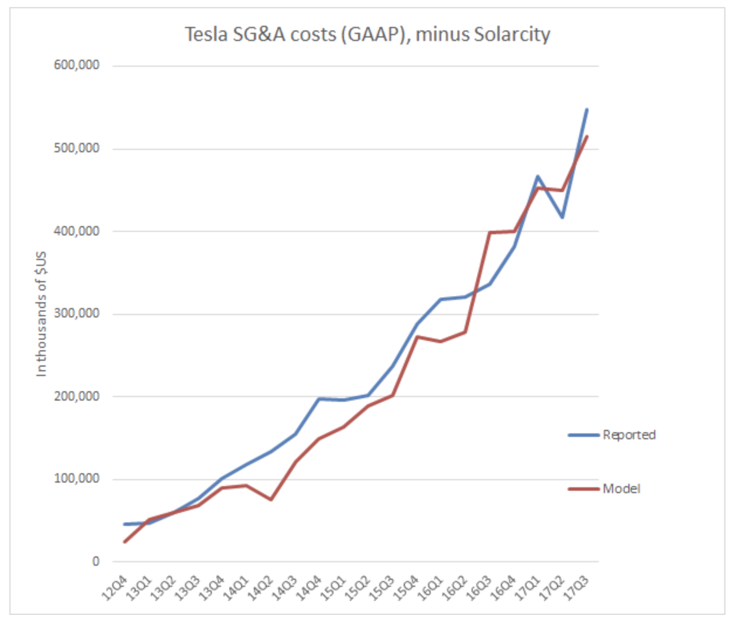

Synergistically, Tesla’s operations management team aims to improve operational efficiency in multiple areas going forward (Thompson). One such area is process and capacity design. Tesla hopes to boost productivity through increased automation, mainly by raising the machine to human ratio in the factory. The second area of improvement is quality management. By assuring more accurate quality metrics, Tesla will save on the number of personnel required to check, and eventually redo and replace sub-standard car parts. A third area is layout design and strategy. Optimizing this area will streamline processes and maximize utilization of equipment and facilities, and integrate advanced internal communication. A fourth area of improvement is resource scheduling, such as planning equipment usage as well as ordering in a timely manner ensure maximum slack for critical chain processes. This, coupled with a fifth point about inventory management, can ensure a consistent throughput of cars through each part of the process. As Tesla’s operations managers focus on improving these five areas, Tesla’s SG&A will likely increase at a slower rate relative to revenue as the company continues to grow. As a result, margins will increase and profitability becomes more likely.

A final area of focus is Tesla’s significant R&D costs, and how those costs currently don’t fulfill their ROI potential. The R&D costs for the physical parts of the car are always going to be necessary, especially for Tesla to retain their innovation leader status. But, there is another component: the software. Tesla has often been called a software company that happens to produce cars, and this sentiment will be the basis for new applications of their R&D projects. One such project - arguably their most expensive and advanced - is Autopilot. Developing a team, planning data acquisition, building and deploying sensors, testing, and iterating to develop capable software takes a lot of capital. In fact, Tesla spends (as a percent of revenue) 3x as much on R&D as the industry average of car manufacturers.

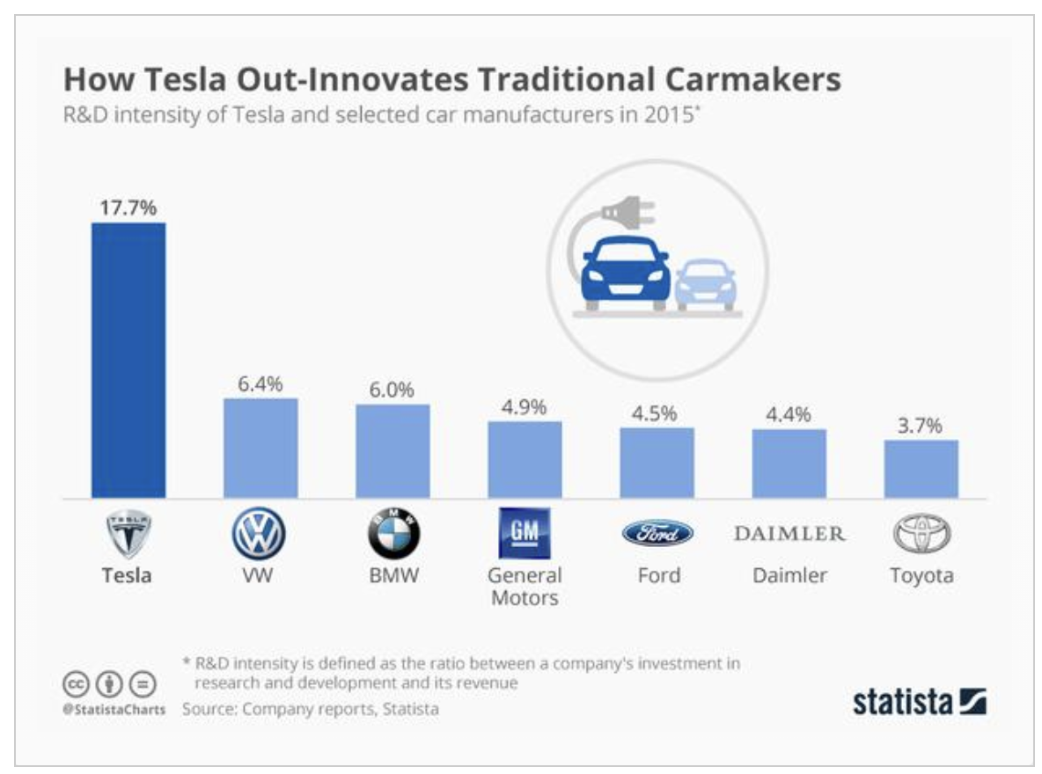

(Pressman)

Tesla’s large R&D costs lead to its status as an innovation leader. Lot’s of it directly pays of with ROI that comes directly from sales of innovative cars, but a portion of the R&D has almost zero ROI at the moment - the software. R&D costs that go into the Autopilot platform are simply a money sink at the moment. Tesla has the potential to utilize this AI technology, and exploit its value in a freemium model. A freemium model would allow Tesla to get higher margins on each car. Tesla currently plans to have people pay a premium for the extra hardware that makes Autopilot possible with their car. But, this premium will only have Tesla break even, rather than gain additional revenue (Comendador). In addition, Tesla could capitalize on the massive savings drivers will experience with reduced auto insurance due to the increased safety and reliability of self-driving cars. Tesla would essentially take a fraction of the money that was going to traditional insurance providers as a premium for their Autopilot feature. This would increase margins and profitability for the software R&D that is otherwise a money sink for the foreseeable future.

In summary, a 3-pronged attack towards economies of scale through the Gigafactory, strides towards increased operational efficiency, and offsetting software R&D costs through a freemium model will increase Tesla’s margins and keep costs relative to revenue down. With these advances, profitability will be achievable, and Autopilot will be able to fulfill its purpose of differentiation through innovation. Each of these three areas has specific focuses that Tesla can exploit to craft a new business model to combat unprofitability, as elaborated on in the next section.

Proposed solution

To answer the strategic issue of Tesla’s unprofitability, we recommend Tesla begin to separate its digital products from its physical products. By splitting these two aspects of the business, Tesla can then begin to introduce a “freemium” product to its consumers. We also recommend that Tesla introduce a more affordable, non-customizable version of its cars.

Tesla’s vehicles are already tightly entwined with the digital hub they have produced, and the foundation of the company is more aligned with an IT company than an automotive manufacturer. Elon Musk himself stated that the company's cars are more like “sophisticated computer[s] on wheels” rather than simple motor vehicles (qz.com). Therefore we must attempt to analyze Tesla in a different light, and there are three distinct products that can be evaluated for profitability potential and ability to maintain long term advantage over competitors:

* Vehicles
* Batteries
* Technology

Vehicles

Tesla’s vehicles are the company’s top source of income, and it is heavily invested in vehicle innovation. However, you must consider a few reasons as to why this will not be the product that leads to the success of Tesla. First, they have already open-sourced their electric technology for the world to use for free. Musk has been a major advocate in pushing for a better, more environmentally friendly world, and he proved this by giving his highly advanced and competitively dominant engineering blueprints to the world (tesla.com). This may have increased Tesla’s brand recognition and position, but financially and competitively Tesla has given up one of their most expensive and highly sought out market advantages. Because Tesla doesn’t have the manufacturing infrastructure of major motor manufacturers such as Ford, GM and Toyota, this could have been a fatal mistake.

Currently, Tesla is struggling to produce a substantial amount of vehicles and is far below their goal set by Musk at the beginning of 2017 to be producing 20,000 Model 3 cars per month. A major motor company such as Ford has substantially more manufacturing capacity than Tesla, and due to the open-source blueprints, there is nothing stopping a major company from mimicking Tesla’s engineering design and out-producing them. If this were to happen, Tesla would be forced to lower prices to match their competitor, and with the fragile state the company is currently in, they would surely go bankrupt. Since the physical vehicles can be easily imitated by competitors, they have lost their innovative advantage and in order to compete would have to choose either becoming a cost leader or operationally more efficient, both of which positions would be challenged by an already established major manufacturer.

The addition of a non-customizable, affordable, vehicle could be the start of turning the company’s profits around. Traditionally Tesla has gone for an unorthodox strategy of entering the market from the top down rather than the bottom up. Instead of entering the market with a cost leading, affordable electric car, they entered with their highest priced vehicle, the Tesla Roadster. Although their strategy has been successful in creating a unique brand, they have missed out on revenues from the average consumer. With the release of the Model 3, Tesla touched on some of this market, but the company is still missing out on having base models for each of its vehicles. Having a cheaper base model means limiting the digital and physical add-ons for the vehicle. This would allow more Teslas to enter the open road and increase recognition for the brand while also generating more stable revenues. Then, Tesla could exploit its technology in a different way that we will expand on in the “Technology” section. If Tesla solely relies on its vehicles to turn a profit it would be critical error in their business strategy, and in order for them to be successful they must exploit one of their other products as their competitive advantage.

Batteries

Tesla has developed a massive, high-risk project with the Gigafactory. The factory is large enough to meet the demand of batteries needed for large-scale manufacturing of electric vehicles. Currently there is no other company or factory that could manufacture enough high quality customized batteries needed in Electric vehicles. It seems that if all goes well for Tesla, the investment could pay off big time as they are becoming the leading vehicle battery producer in the world. Additionally, if other automotive manufacturers follow in Tesla’s footsteps to produce electric vehicles, Tesla will be the cost leader for large batteries and could make immense profits from selling to other car manufacturers. If production stalls however, Tesla could be in huge trouble. Tesla does currently sell batteries for uses other than powering vehicles, but the demand for this is extremely low compared to the factory’s capacity. If vehicle manufacturing stalls, Tesla would be sitting on a giant factory that accrues extremely high expenses. With a time bomb of costs dependent on vehicle production, Tesla has taken a massive risk in the Gigafactory. And, what’s to stop another battery company from building their own factory and selling to Tesla’s competitors. Investing in the Gigafactory can be a major advantage for Tesla, but experts say time is limited as competing battery manufacturers can catch up within a year or two with their own battery factories(vox.com).

Technology

The most advantageous product Tesla currently owns is its digital systems. Tesla is known to have some of the most advanced vehicles to date and the reason for this is the extensive amount of money the company has poured into the R&D of its digital features. One of Tesla’s most prized applications is Tesla Autopilot. Tesla is currently the only company that has actual vehicles in the consumer's hands with self-driving capabilities. The algorithms behind autopilot are extremely hard to create, let alone test, and the time and resource allocation it takes for this system to mature requires a staggering amount of money. Because of the data you must collect in order to let an AI learning system be anywhere near production level, it is extremely difficult for competitors to imitate and match the quality of this product. Unlike most physical or even digital products, to imitate this AI system would take years of R&D and data collection to be ready for consumer use.

Since Tesla’s digital systems are so advantageous, we believe that focusing efforts on them is the best way for Tesla to begin to turn a profit. In order to turn a profit, we must not look at Tesla as a motor company but rather a technology company. Using Tesla’s vehicles as the base-line “application”, the standard car coming out of Tesla’s manufacturing facilities would have all of the design and engineering features as any of its other cars. However, Tesla can separate its digital systems and use them as API’s rather than default systems in the car. Tesla can then focus on developing different API’s or “features” to add to their “application” (car) to add customizable value to each vehicle it manufactures without actually changing the vehicle itself. With these separate API’s Tesla can charge a monthly premium fee to its consumers in order for them to use each feature, such as Autopilot. For more simple features such as a music application, Tesla could make them free or a one time buying price. They can also introduce bundling off of these products, and many more different ways to earn profits, but the most important thing being the platform they would develop by splitting the physical and digital products.

In order for our recommended Freemium product to be successful, Tesla would need to incorporate the current market share they own into their digital platform as fast as possible. The sooner Tesla could get its consumers on board, the faster the value of the network would rise. Because no other motor company has the same technology base that Tesla current has in every vehicle, Tesla could easily get a jump on the market and expand its platform to become one of the largest vehicle networks in the world.

We have seen many different platforms perform very successfully by splitting their physical and digital mediums. Take Apple for example. Apple’s successful line of iPhones is not what creates the full value of Apple products, but rather it is the digital technologies that support it, such as the app store. The app store has been a constant source of revenue, allowing Apple continue its line of physical products. This platform also introduced high switching costs that made transferring from the Apple platform difficult because other companies did not have the same applications and consumer network that Apple had managed to create. Thus, through our evaluation, splitting the digital products could produce a platform that mimics that of an Apple or Android market where Tesla’s Vehicles become a benefactor to the digital medium that can be spread across all Tesla products, and thus create a network effect.

The creation of this digital platform will be extremely hard to imitate by competitors. If Tesla can get developers to begin to use their platform for development, Tesla can grab the consumer market share as well as the developer market share. This will create an environment of constant income that can become a cash cow for Tesla to exploit. The returns from this can go towards improving Tesla’s struggling manufacturing, allowing it to be pushed up to par with leading motor manufacturers.

Performance Metrics

After the implementation of our solution we believe there will be a drastic increase in the performance of the company in the long run since Tesla will be able to optimize its new platform. In terms of performance metrics, Tesla can measure itself by measuring units of production and car sales while steadily increasing R&D and decreasing the ratio of R&D to revenue. While transitioning to a platform can be expensive, we believe in that the long run it will bear positive results for Tesla. A proper time frame that the company can implement the recommendations would be in about 2-5 years mainly because competitors would begin entering market in about 2-3 years with self-driving electric cars of their own. By 2019, we believe Tesla can implement our recommendations and stay ahead in the production while simultaneously adhering to achieving economies of scale in the marketplace.

Limitations and Future Work

While trying to propose a solution to Tesla’s profitability problems, clear limitations on our research and recommendations emerged. Among the most critical limitations was the lack of guiding examples on which to base our recommendations. Very few innovations have ever made a change as radical as self-driving to an industry as developed and omnipresent as automotives. For this reason, we had to think entirely out of the box for how self-driving could be sold. Without any concrete data of how a freemium model could affect the sales of a self-driving car, we were left with intuition and market savvy on how freemium models and radical innovations of the past have worked.

Conclusion

In conclusion, Tesla’s main strategic issue is its lack of profitability. By focusing on reducing SG&A through increased operational efficiency, taking advantage of economies of scale, and offsetting R&D through alternative means, Tesla can address this issue properly. We propose that Tesla adopt a Freemium model for using Autopilot, as well as creating a non-customized base model car. These two recommendations will help Tesla attain profitability by:

* Offsetting Autopilot R&D costs through a monthly subscription fee
* Reducing SG&A through efficient production
* Taking advantage of economies of scale through the Gigafactory and increasing production volume

If Tesla follows these recommendations to achieve profitability, we believe it is possible for Tesla to grasp the first-mover advantage in the self-driving car market. Tesla’s “sophisticated computer on wheels” is certainly the car of the future and it most likely is the example that other companies will follow. Once companies begin to imitate how Tesla is doing business, however, it might be difficult for Tesla to compete against them if it cannot fix its current profitability problems. Thankfully, we believe that our recommendations of separating physical products and digital products along with introducing a Freemium model and creating a non-customizable, base model can certainly help Tesla avoid losing position as the golden standard for the vehicles of the future.

Works Cited

Bongdanov, Vik. “ WHAT IT'S LIKE TO BE A PRINCIPLE DATA ARCHITECT AT TESLA MOTORS” Intersog.com, 11 Apr. 2017, <https://intersog.com/blog/software-teams/what-its-like-to-be-a-principle-data-architect-at-tesla-motors/>

Brusewitz, Garrett. “Tesla: The Gigafactory Is The Key.”*Seeking Alpha*, 20 Jan. 2017, <http://seekingalpha.com/article/4038307-tesla-gigafactory-key>

Comendador, Alberto Zaragoza. “Tesla's SG&A Costs: Out Of Control.” *Seeking Alpha*, 13 Nov. 2017, <http://seekingalpha.com/article/4124421-teslas-sg-costs-control>

Davis, Scott. “Tesla, Tesla, Tesla: Building A Power Brand From Scratch.” Forbes, Forbes Magazine, 24 Feb. 2014, [www.forbes.com/sites/scottdavis/2014/02/24/tesla-tesla-tesla-building-a-power-brand-from-scratch/#90237527e315](http://www.forbes.com/sites/scottdavis/2014/02/24/tesla-tesla-tesla-building-a-power-brand-from-scratch/#90237527e315).

DeBord, Matthew. “Elon Musk is setting himself up for an epic failure” businessinsider.com, 7 May. 2016, <http://www.businessinsider.com/musk-epic-failure-2016-5>

DeBord, Matthew. “Elon Musk just made a totally mind-blowing change to Tesla's strategy” businessinsider.com, 7 May. 2016, <http://www.businessinsider.com/tesla-mind-blowing-change-strategy-2016-5>

Eady, Trent. “Tesla Leapfrogs Self-Driving Competitors With Radar That's Better Than Lidar” seekingalpha.com, 9 May. 2017, <https://seekingalpha.com/article/4071192-tesla-leapfrogs-self-driving-competitors-radar-better-lidar>

Halla, Brian. ”Piecing Together the Tesla Strategy Puzzle” HBR.org, 16 Sept. 2015, <https://hbr.org/2015/09/piecing-together-the-tesla-strategy-puzzle>

Hu, Charlotte, et al. “*Tesla Autopilot and Artificial Intelligence: The Unfair Advantage.*“ TESLARATI.com, 6 July 2017 [www.teslarati.com/tesla-autopilot-ai-artificial-intelligence-unfair-advantage/](http://www.teslarati.com/tesla-autopilot-ai-artificial-intelligence-unfair-advantage/)

Ingraham, Christopher. “The astonishing human potential wasted on commutes” washintonpost.com, 26 Feb. 2016, <https://www.washingtonpost.com/news/wonk/wp/2016/02/25/how-much-of-your-life-youre-wasting-on-your-commute/?utm_term=.187329819f93>

Lambert, Fred. “Tesla Is Now Claiming 35% Battery Cost Reduction at ‘Gigafactory 1’ – Hinting at Breakthrough Cost below $125/KWh.” *Electrek*, 18 Feb. 2017, <https://electrek.co/2017/02/18/tesla-battery-cost-gigafactory-model-3/.>

Musk, Elon. “All Our Patent Are Belong To You” tesla.com, 12 Jun. 2014, <https://www.tesla.com/blog/all-our-patent-are-belong-you>

Pressman, Matt. “Culture of Innovation: Tesla Has Triple the R&D of Traditional Automakers [Infographic].” *Evanex*, 4 Nov. 2016, <https://evannex.com/blogs/news/innovation-culture-tesla-r-d-spending-versus-other-automakers.>

Ryan, Kevin J. “*Tesla Explains How A.I. Is Making Its Self-Driving Cars Smarter.*” Inc.com, Inc., 13 Sept. 2016, [www.inc.com/kevin-j-ryan/how-tesla-is-using-ai-to-make-self-driving-cars-smarter.html](http://www.inc.com/kevin-j-ryan/how-tesla-is-using-ai-to-make-self-driving-cars-smarter.html).

Thompson, Andrew. “Tesla Motors, Inc.'s Operations Management: 10 Decisions, Productivity.” *Panmore Institute*, 21 Feb. 2017, [https://panmore.com/tesla-motors-inc-operations-management-10-decisions-areas-productivity](https://panmore.com/tesla-motors-inc-operations-management-10-decisions-areas-productivity.)

Wolters, Vincent. “Tesla: A Closer Look At Margins And Profitability.”*Seeking Alpha*, 23 May 2017, <http://seekingalpha.com/article/4075701-tesla-closer-look-margins-profitability>

“Autopilot.” *Tesla, Inc*, [www.tesla.com/autopilot](http://www.tesla.com/autopilot).

*“The World's Most Innovative Companies*” Forbes, Forbes Magazine, [www.forbes.com/innovative-companies/#367d8f1a1d65](http://www.forbes.com/innovative-companies/#367d8f1a1d65)

Acknowledgments

No outside persons were involved in the creation of this project.